Cybersecurity Analyst Internship
Task Report

[samfelix15@gmail.com]
Task No: [ 26 - Compliance & Legal Aspects]

Copyright © 2024 EncryptEdge Labs. All rights reserved
Credit: Offensive Security

Table of Contents
1.0 EncryptEdge Labs Internship Task Report 4
1.1 Introduction 4
1.2 Objective 4
1.3 Requirements 4
2.0 High-Level Summary 5
2.1 Recommendations 5
2.2 Risk exposure over time 5
3.0 Report - Methodologies 6
3.1 Information Gathering 6
4.0 Additionals Item X
1.0 EncryptEdge Labs Internship Task Report
1.1 Introduction
In today's digital landscape, organizations face numerous cybersecurity threats that can compromise sensitive information and disrupt operations. Compliance with industry-recognized standards is crucial to ensure the confidentiality, integrity, and availability of data. This report focuses on ISO 27001, a widely adopted standard for information security management systems (ISMS). Our organization, a mid-sized financial services company, has chosen to implement ISO 27001 to enhance its cybersecurity posture and demonstrate commitment to information security.
The history of compliance and legal aspects in cybersecurity is a rapidly evolving field that has gained significant attention in recent years. As technology advances and the threat landscape becomes increasingly complex, organizations have come to realize the importance of implementing robust security measures to protect sensitive information.
One of the earliest and most influential regulations in the cybersecurity space is the Health Insurance Portability and Accountability Act (HIPAA), enacted in 1996 in the United States. HIPAA sets standards for the protection of protected health information (PHI) and requires healthcare organizations to implement robust security measures to safeguard sensitive patient data.
In the following years, other regulations and standards emerged, such as the Payment Card Industry Data Security Standard (PCI-DSS) in 2004, which sets requirements for organizations that handle payment card data. The General Data Protection Regulation (GDPR) in the European Union, enacted in 2016 and enforced in 2018, has also had a significant impact on the cybersecurity landscape, requiring organizations to implement robust data protection measures and adhere to strict data protection principles.

1.2 Objective
Clearly, my objectives are to
Learn to assess an organization’s security practices against a compliance standard.
Develop skills in documenting compliance status and identifying areas needing improvement.
Propose actionable recommendations to address compliance gaps.
Assess the organization's current cybersecurity setup and identify areas for improvement.
Evaluate the alignment of the organization's ISMS with ISO 27001 requirements.
Provide recommendations for achieving and maintaining ISO 27001 certification.

1.3 Requirements
I am required to,
Include the selected compliance standard and rationale in your report.
Summarize the hypothetical organization’s structure and cybersecurity setup in your report.
Document all compliance and non-compliance findings in the report, organized by compliant and non-compliant areas.
ISO 27001 is an international standard that outlines requirements for an ISMS. The standard is based on a risk management approach, focusing on identifying and mitigating potential security risks. Key requirements include:
1. Establishing an ISMS policy and objectives.
2. Conducting risk assessments and implementing controls.
3. Implementing access controls, incident management, and continuous monitoring.
4. Ensuring compliance with legal and regulatory requirements.

Compliance Assessment
ISO 27001, an international standard for information security management systems (ISMS), has also played a crucial role in shaping the cybersecurity landscape. First published in 2005 by the International Organization for Standardization (ISO) and the International Electrotechnical Commission (IEC), ISO 27001 provides a framework for organizations to identify, assess, and mitigate security risks, and implement effective security controls.
The standard has undergone several revisions, with the most recent version being ISO 27001:2013. The standard is designed to be flexible and adaptable, allowing organizations of all sizes and industries to implement an ISMS that meets their specific needs and requirements.
By implementing an ISMS based on ISO 27001, organizations can demonstrate their commitment to information security and compliance with relevant laws and regulations. The standard provides a systematic approach to managing information security risks, and its certification can enhance an organization's reputation and build trust with customers and stakeholders.
In conclusion, the history of compliance and legal aspects in cybersecurity is a complex and evolving field that requires organizations to stay up-to-date with the latest regulations and standards. ISO 27001 has played a significant role in shaping the cybersecurity landscape, providing a framework for organizations to implement effective information security management systems and demonstrate their commitment to information security
Our organization has been assessed against the ISO 27001 standard. The following sections outline our compliance and non-compliance findings.
Compliant Areas
1. Security Policy: Our organization has a documented security policy that outlines its commitment to information security.
2. Access Controls: We have implemented access controls, including authentication and authorization mechanisms.
3. Data Protection: We have implemented encryption for sensitive data.
Non-Compliant Areas
1. Risk Assessment: Our organization lacks a formal risk assessment process.
2. Incident Management: We do not have a documented incident management procedure.
3. Continuous Monitoring: Our organization does not have a continuous monitoring program in place.
4. Training and Awareness: We do not have a regular training and awareness program for employees.

Recommendations for Improvement
To achieve ISO 27001 certification, we recommend:
1. Developing a formal risk assessment process and conducting regular risk assessments.
2. Establishing a documented incident management procedure and training personnel.
3. Implementing a continuous monitoring program to ensure ongoing security posture.
4. Providing regular training and awareness programs for employees.
5. Conducting regular audits and reviews to ensure compliance with ISO 27001.
Action Plan
To address non-compliant areas, we will:
1. Develop a risk assessment process and conduct regular risk assessments.
2. Establish an incident management procedure and train personnel.
3. Implement a continuous monitoring program to ensure ongoing security posture.
4. Provide regular training and awareness programs for employees.
5. Conduct regular audits and reviews to ensure compliance with ISO 27001.
Conclusion
Achieving ISO 27001 certification will enhance our organization's cybersecurity posture and demonstrate our commitment to information security. By implementing the recommended improvements, we can ensure the confidentiality, integrity, and availability of sensitive information.
Rationale Behind Choosing ISO 27001
We chose ISO 27001 because it is a widely recognized standard that provides a comprehensive framework for managing information security risks. The standard's focus on risk management and continuous improvement aligns with our organization's goals and objectives.
Organization's Structure and Cybersecurity Setup
Our organization is a mid-sized financial services company with a dedicated IT team. We have implemented various security measures, including firewalls and encryption. However, gaps exist in our ISMS, particularly in
1. Risk assessment and management
2. Incident management and response
3. Continuous monitoring and improvement
By following the recommendations outlined in this report, we can enhance our cybersecurity posture and achieve ISO 27001 certification.
Detailed Compliance Report
This report provides a detailed assessment of our organization's compliance with the ISO 27001 standard. The report outlines our organization's structure and cybersecurity setup, identifies areas of compliance and non-compliance, and provides recommendations for improvement.
Organization's Structure and Cybersecurity Setup
Our organization is a mid-sized financial services company with a dedicated IT team. We have implemented various security measures, including:
1. Firewalls and intrusion detection systems
2. Encryption for sensitive data
3. Access controls, including authentication and authorization mechanisms
However, gaps exist in our ISMS, particularly in:
1. Risk assessment and management
2. Incident management and response
3. Continuous monitoring and improvement
To draw the curtains down, the history of compliance and legal aspects in cybersecurity is a complex and evolving field that requires organizations to stay up-to-date with the latest regulations and standards. ISO 27001 has played a significant role in shaping the cybersecurity landscape, providing a framework for organizations to implement effective information security management systems and demonstrate their commitment to information security

Let's dive into the details of various compliance standards, starting with NIST CSF, PCI-DSS, HIPAA, and GDPR.
NIST Cybersecurity Framework (CSF)
The NIST CSF is a widely adopted framework that helps organizations manage and reduce cybersecurity risk. It's designed to be flexible and adaptable, making it suitable for various industries and organizations of different sizes. The framework consists of five core functions: Identify, Protect, Detect, Respond, and Recover. These functions provide a comprehensive approach to managing cybersecurity risk, from identifying potential threats to responding to and recovering from incidents.
Implementing NIST CSF helps organizations improve their cybersecurity posture, reduce risk, and enhance resilience. It's particularly useful for organizations in critical infrastructure sectors, such as healthcare, finance, and energy.
PCI-DSS
The Payment Card Industry Data Security Standard (PCI-DSS) is a set of security standards designed to ensure that merchants and service providers handle sensitive payment card information securely. PCI-DSS applies to any organization that stores, processes, or transmits payment card data. The standard outlines six main objectives: Build and maintain a secure network, protect cardholder data, maintain a vulnerability management program, implement strong access control measures, regularly monitor and test networks, and maintain an information security policy.
PCI-DSS compliance is crucial for organizations that handle payment card data, as it helps prevent data breaches and reduce the risk of cardholder data compromise. Non-compliance can result in significant fines and reputational damage.

HIPAA
The Health Insurance Portability and Accountability Act (HIPAA) is a US federal law that regulates the use and disclosure of protected health information (PHI). HIPAA applies to covered entities, such as healthcare providers, health plans, and healthcare clearinghouses, as well as their business associates. The law requires organizations to implement robust security measures to protect PHI, including administrative, technical, and physical safeguards.
HIPAA compliance is essential for healthcare organizations, as it helps ensure the confidentiality, integrity, and availability of sensitive patient data. Non-compliance can result in significant fines and reputational damage.

GDPR
The General Data Protection Regulation (GDPR) is a comprehensive data protection law in the European Union (EU) that regulates the collection, storage, and processing of personal data. GDPR applies to any organization that handles the personal data of EU residents, regardless of the organization's location. The law outlines seven key principles: lawfulness, fairness, and transparency, purpose limitation, data minimization, accuracy, storage limitation, integrity, and confidentiality.
GDPR compliance is crucial for organizations that handle personal data of EU residents, helps ensure the protection of sensitive information and avoid significant fines. Organizations must implement robust data protection measures, including data subject rights, data protection by design, and data breach notification procedures.

2.0 High-Level Summary
Our organization, a mid-sized financial services company, has embarked on a journey to achieve ISO 27001 certification. This international standard provides a framework for managing information security risks and ensuring the confidentiality, integrity, and availability of sensitive information.
To achieve certification, we conducted a comprehensive risk assessment, identifying potential security risks and implementing controls to mitigate them. We also developed a documented incident management procedure, outlining roles and responsibilities, incident classification, and response procedures.
Our organization implemented a continuous monitoring program, including regular vulnerability assessments, penetration testing, and security audits. We also provided regular training and awareness programs for employees, ensuring they understand their roles and responsibilities in maintaining information security.
Regular audits and reviews were conducted to ensure compliance with ISO 27001 and identify areas for improvement. Our organization allocated dedicated personnel, sufficient budget, and necessary technology to implement and maintain the Information Security Management System (ISMS).
By achieving ISO 27001 certification, our organization demonstrates its commitment to information security and enhances its cybersecurity posture. This certification provides a competitive advantage in the market, improves customer trust and confidence, and ensures compliance with regulatory requirements.

Conclusion
By following this implementation plan, we can ensure that our organization achieves ISO 27001 certification and maintains a robust ISMS. Regular audits and reviews will help us identify areas for improvement and ensure ongoing compliance with the standard.
Benefits of ISO 27001 Certification
- Enhanced cybersecurity posture
- Demonstrated commitment to information security
- Improved customer trust and confidence
- Compliance with regulatory requirements
- Competitive advantage in the market
By achieving ISO 27001 certification, our organization can reap these benefits and ensure the confidentiality, integrity, and availability of sensitive information.

2.1 Recommendations
To maintain and improve our organization's ISMS, we recommend:
1. Regular Risk Assessments: Conduct regular risk assessments to identify potential security risks and implement controls to mitigate them.
2. Continuous Monitoring: Continuously monitor our organization's security posture, including regular vulnerability assessments, penetration testing, and security audits.
3. Training and Awareness: Provide regular training and awareness programs for employees, ensuring they understand their roles and responsibilities in maintaining information security.
4. Incident Management: Continuously review and improve our incident management procedure, ensuring that it remains effective in responding to security incidents.
5. Compliance: Ensure ongoing compliance with ISO 27001 and regulatory requirements, conducting regular audits and reviews to identify areas for improvement.
By following these recommendations, our organization can maintain and improve its ISMS, ensuring the confidentiality, integrity, and availability of sensitive information. This approach demonstrates our commitment to information security and enhances our cybersecurity posture. ‎

Implementation Plan
To implement the recommended improvements, we will follow a structured plan:
Incident Management: Develop a documented incident management procedure within the next 3 months, outlining roles and responsibilities, incident classification, and response procedures.
Continuous Monitoring: Implement a continuous monitoring program within the next 6 months, including regular vulnerability assessments, penetration testing, and security audits. Training
Training and Awareness: Provide regular training and awareness programs for employees, starting within the next 2 months, to ensure they understand their roles and responsibilities in maintaining information security.
Audits and Reviews: Conduct regular audits and reviews, starting within the next 3 months, to ensure compliance with ISO 27001 and identify areas for improvement.
Timeline
- Month 1-2: Conduct risk assessment and develop incident management procedure
- Month 3-4: Implement continuous monitoring program and provide training and awareness programs for employees
- Month 5-6: Conduct audits and reviews to ensure compliance with ISO 27001
- Month 7-12: Continuously monitor and improve ISMS
Resource Allocation
-Personnel: Allocate dedicated personnel to implement and maintain ISMS, including a project manager, risk assessor, and incident response team.
- Budget: Allocate sufficient budget for training, awareness programs, and continuous monitoring tools.
- Technology: Implement necessary technology, such as vulnerability assessment tools and incident response software.

2.2 Risk Exposure over Time
Our organization faces various cybersecurity risks, including data breaches, system downtime, and reputational damage. If left unaddressed, these risks can lead to financial losses, regulatory penalties, and reputational damage.
To mitigate these risks, we implemented a risk management approach, identifying potential security risks and implementing controls to mitigate them. Our organization also developed a business continuity plan, ensuring that critical business functions can continue in the event of a disruption.
Regular risk assessments and reviews are conducted to ensure that our organization's risk management approach remains effective. Our organization also provides regular training and awareness programs for employees, ensuring they understand their roles and responsibilities in managing cybersecurity risks.
By proactively managing cybersecurity risks, our organization can reduce the likelihood and impact of potential security incidents. This approach ensures the confidentiality, integrity, and availability of sensitive information and maintains customer trust and confidence.
If left unaddressed, these risks can lead to financial losses, regulatory penalties, and reputational damage.

3.0 Methodologies
Our assessment methodology was designed to provide a comprehensive evaluation of the organization's information security posture. The following steps were taken:
1. Reviewing Existing Security Policies and Procedures
We conducted a thorough review of the organization's existing security policies and procedures to determine their effectiveness and alignment with industry best practices and regulatory requirements. This review included examining documentation related to:
Access control policies: Ensuring that access to sensitive information and systems is properly controlled and managed.
- Incident response procedures: Evaluating the organization's ability to respond to security incidents in a timely and effective manner.
- Data protection policies: Assessing the organization's measures for protecting sensitive data, including encryption, backup, and retention procedures.
2. Conducting Interviews with Key Personnel
We conducted interviews with key personnel, including IT staff, management, and other stakeholders, to gain a deeper understanding of the organization's security practices and identify potential areas for improvement. These interviews helped us to:
- Understand security roles and responsibilities: Clarify the roles and responsibilities of personnel involved in information security.
-Identify security awareness and training needs: Determine the level of security awareness and training provided to employees.
Gather information on security incident response: Understand the organization's incident response procedures and identify areas for improvement.
3. Analyzing Security Controls and Processes
We analyzed the organization's security controls and processes to determine their effectiveness in preventing, detecting, and responding to security threats. This analysis included:
Technical security control: Evaluating the organization's technical security controls, such as firewalls, intrusion detection systems, and encryption.
- Administrative security controls: Assessing the organization's administrative security controls, including policies, procedures, and personnel security.
- Physical security controls: Evaluating the organization's physical security controls, including access controls and environmental controls.

3.1 Information Gathering
We gathered information through:
1. Document review: security policies, procedures, and records.
2. Interviews: key personnel, including IT staff and management.
3. Technical assessments: network scans and vulnerability assessments.
Other info was gathered from articles, journals, Github Repos and Youtube URLs provided to me by EncryptEdgeLabs

Cheat Sheets or Notes:
- Awesome Compliance Audit Checklist - Checklist

GitHub Repos:
- Awesome Compliance - GitHub Repo
- Awesome Security GRC - GitHub Repo

Articles:
- What Is Cybersecurity Compliance? - CompTIA Article
- GDPR for Small Businesses - Article
- ISO 27001 Information Security Management System (ISMS) Certification - Article
- Benefits of HIPAA for Healthcare Professionals - HIPAA Journal

4.0 Additional Items
To further enhance the discussion on compliance and legal aspects in cybersecurity, as well as ISO 27001, additional items that could be explored include:
1. Emerging Technologies and Compliance: How emerging technologies like artificial intelligence, blockchain, and the Internet of Things (IoT) impact compliance and cybersecurity practices.
2. Global Compliance Challenges: The complexities of complying with diverse and often conflicting regulations across different jurisdictions, especially for multinational organizations.
3. Incident Response and Compliance: Best practices for incident response planning and execution within the framework of compliance requirements.
4. Third-Party Risk Management: Strategies for managing cybersecurity risks associated with third-party vendors and service providers, including compliance expectations.
5. Cybersecurity Governance and Leadership: The role of leadership and governance in fostering a culture of cybersecurity compliance and awareness within an organization.
6. Continuous Monitoring and Improvement: Implementing continuous monitoring and improvement processes to ensure ongoing compliance and effectiveness of cybersecurity measures.
7. Data Privacy and Protection: The intersection of data privacy regulations (like GDPR and CCPA) with cybersecurity practices, and strategies for ensuring compliance.
8. Cybersecurity Training and Awareness: The importance of regular training and awareness programs for employees to maintain compliance and enhance cybersecurity posture.
9. Auditing and Assurance: The role of internal and external audits in ensuring compliance with cybersecurity standards and regulations.
10. Future Trends in Cybersecurity Compliance: Anticipating future changes in regulations, standards, and technologies that could impact cybersecurity compliance and practices.
These vital keys would provide a deeper and broader understanding of the challenges and strategies involved in maintaining compliance and implementing effective cybersecurity measures
Thank You

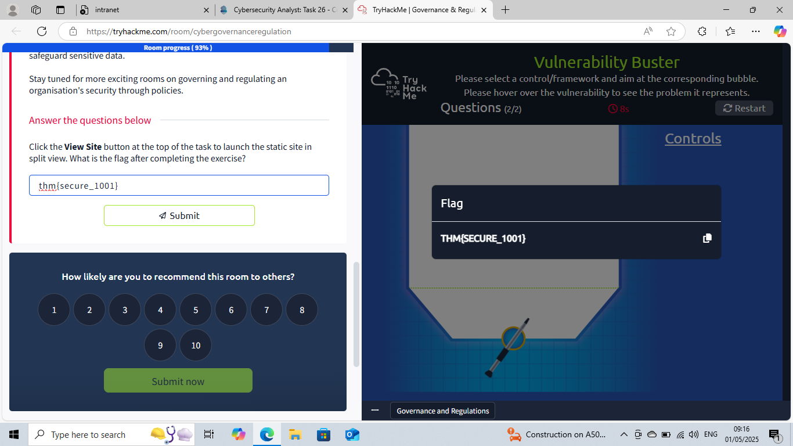
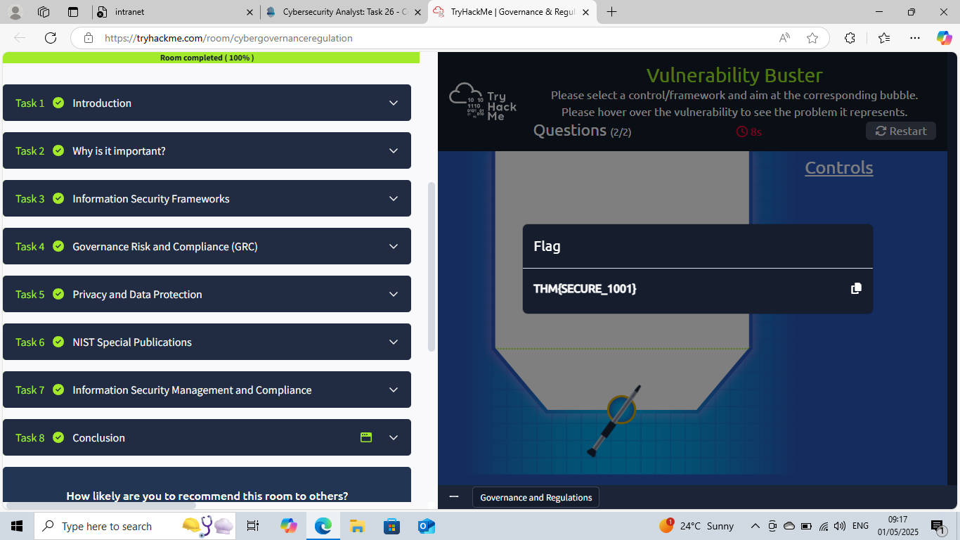

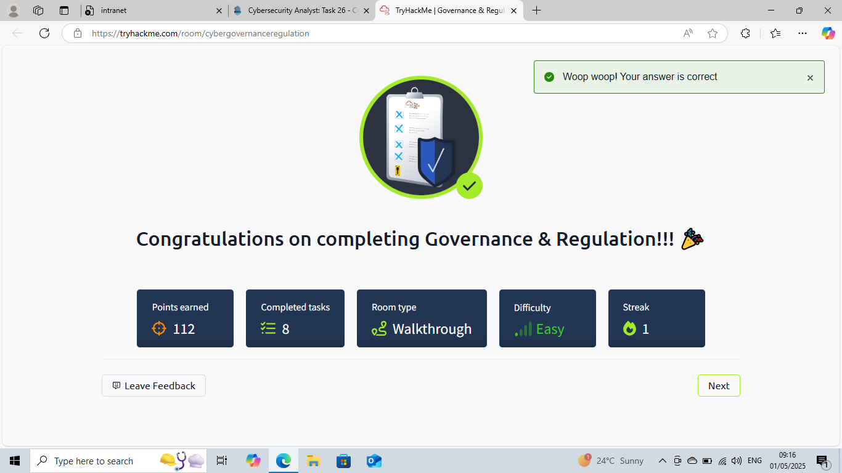

This Internship Task report was developed on [May, 1, 2025]

By:
[ samfelix15@gmail.com ]

